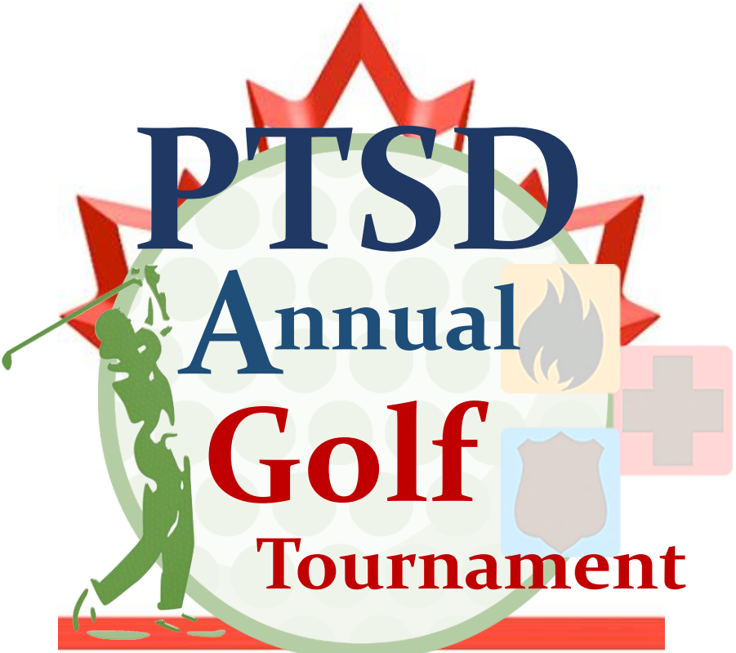

**ANNUAL**

**PTSD GOLF TOURNAMENT**

**IN SUPPORT OF FIRST RESPONDERS & EXTENDED NETWORK**

**WHEN: Saturday, July 8th, 2023**

**11:00 am Registration / 1 PM Shot-gun Tee-off**

Join us for a day of fun and golf at The Oxford Hills Golf Course in Mt Elgin Ontario.

This scramble style tournament is open to everyone in support of First Responders and their extended network.

PTSD First Responders Extended Network has teamed up with Boots on the Ground to bring you a truly spectacular golf experience for a great cause.

All proceeds will assist Boots on the Ground in support of PTSD & Mental Health Initiatives for First Responders.

**Email:** [**PTSD1REN@gmail.com**](mailto:PTSD1REN@gmail.com) **or visit** [**https://ptsd1ren.wixsite.com/mysite**](https://ptsd1ren.wixsite.com/mysite) **for a Registration Form**

**TOURNAMENT REGISTRATION INCLUDES:**

* Green Fee/Cart
* Welcome gift
* Sausage/Hot dog, Pop and chips (12-1PM)
* Ticket to enter for a draw Prize
* Buffet style Dinner

**Par 3 Hole in one prizes!**

**Tournament/hole games: Longest Drive mens and womens, closest to the pin, longest putt and more.**

**See website for details of tournament layout and structure for the day: https://ptsd1ren.wixsite.com/mysite**

